Password protect a document
You can protect a sensitive or confidential document by using a password to help prevent anyone from being able to change or even access it.
- Click File>Info>Protect Document> Encrypt with Password.
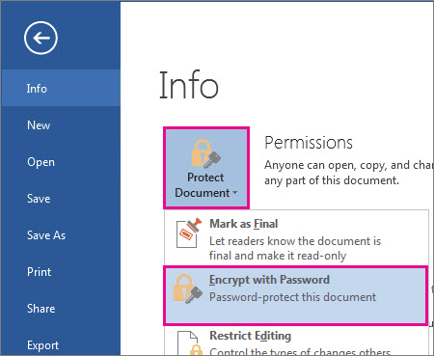
- In the Encrypt Document box, type a password, and then click OK.
- In the Confirm Password box, type the password again, and then click OK.
You can always change or remove your password.
Important
- Passwords are case-sensitive. Make sure that the CAPS LOCK key is turned off when you enter a password for the first time.
- If you lose or forget a password, Word can’t recover your information so it might be a good idea to keep a copy of your password in a safe place or create a strong password that you’ll remember. Read more about resetting or recovering a forgotten password.
Applies To: Word 2013

